Degrees of rotation

0-5 degree – NO MIRROR ON DEFAULT

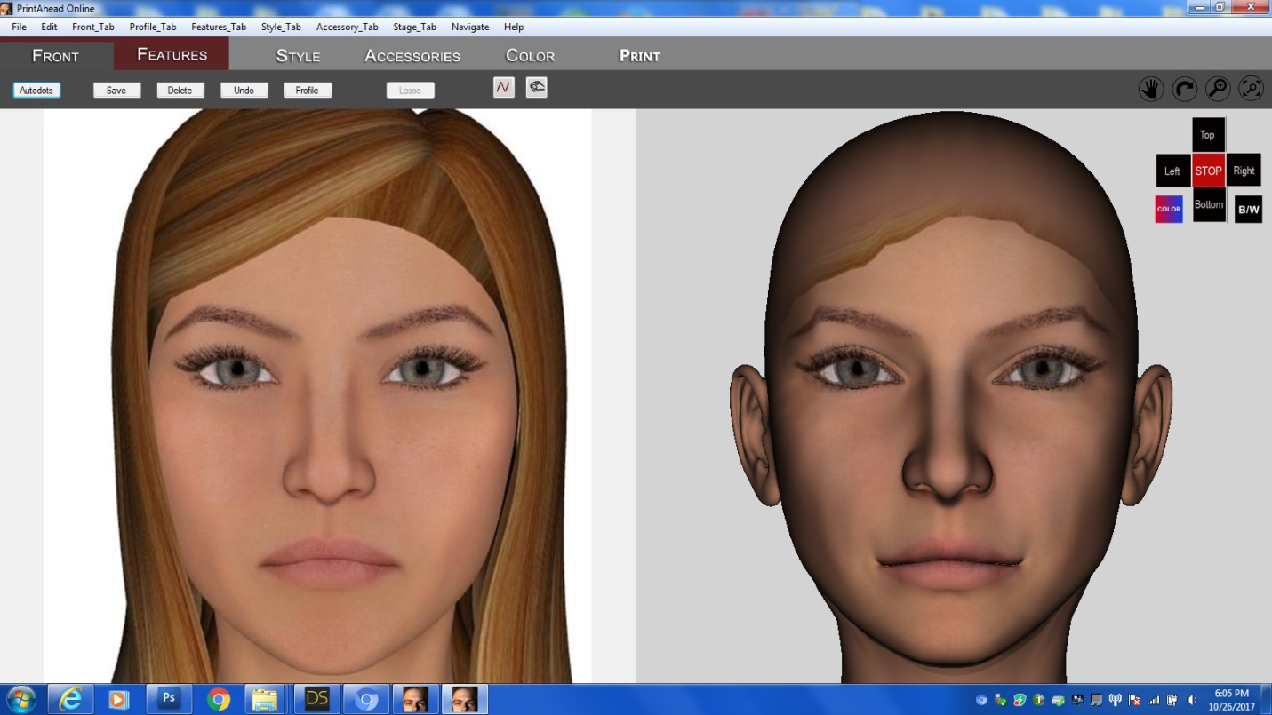

5-10 degree – Mirror on default

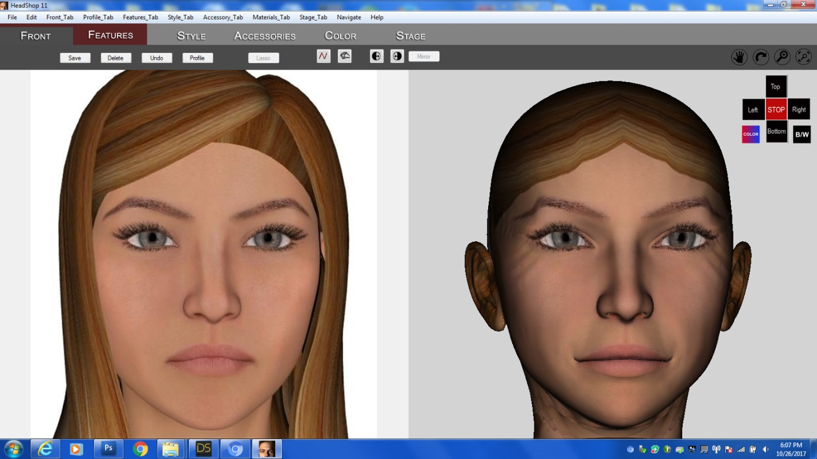

10-15 degree – mirror (issues with wrinkle)

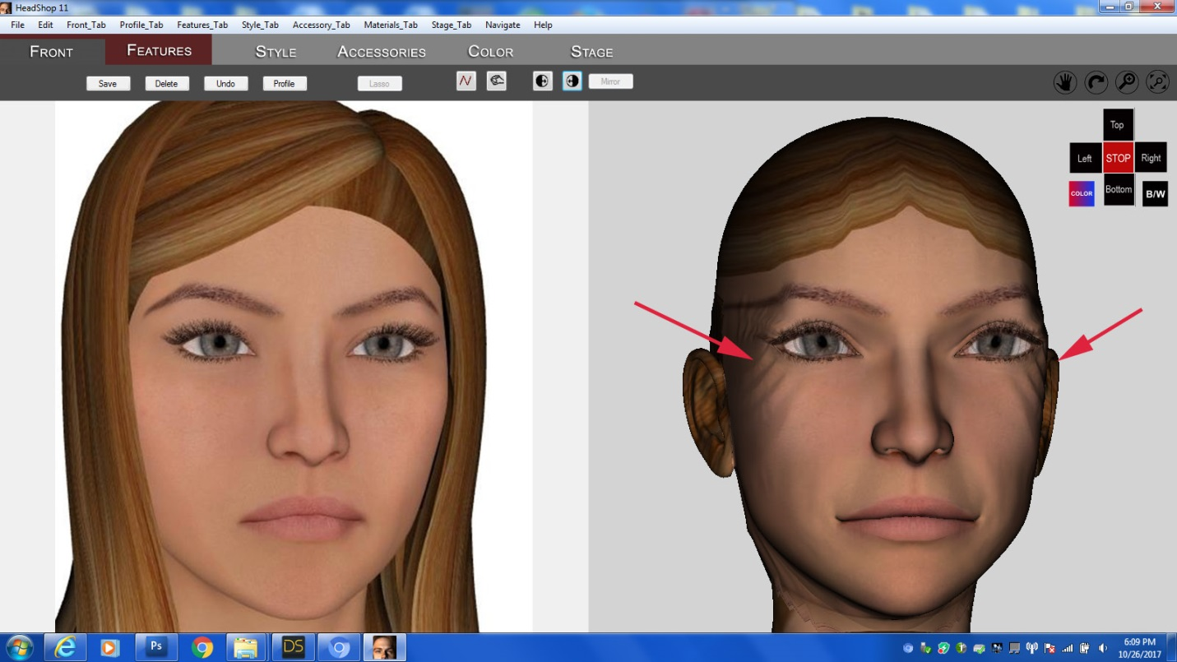

15-20 degree – mirror (wrinkle, bottom half is 5% too wide)

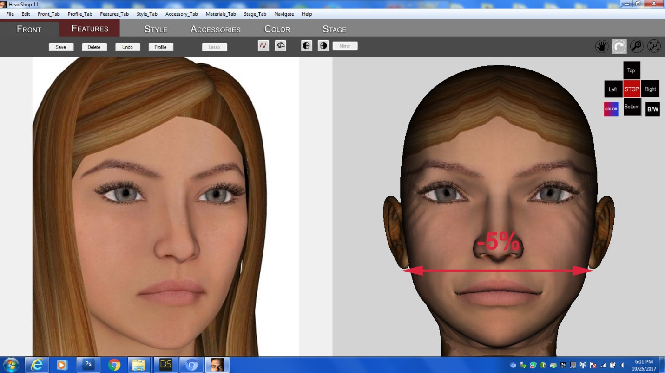

20-25 degree (bottom half 10% too wide)

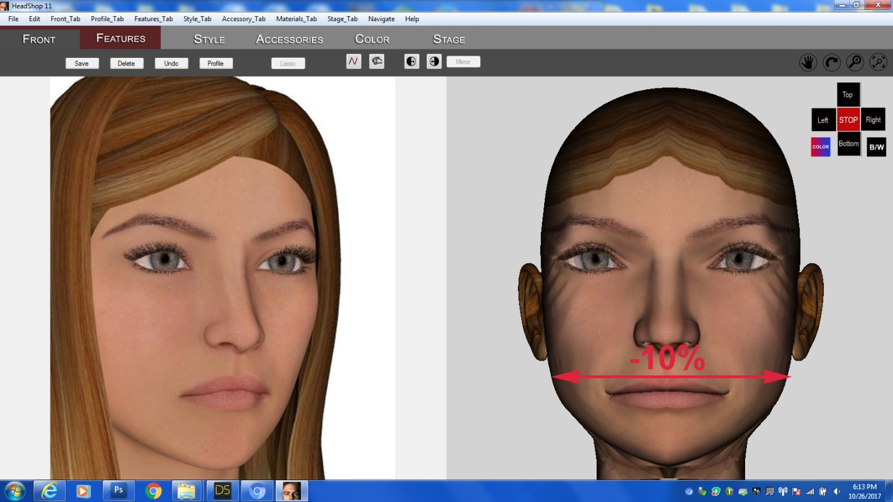

Over 25 degree – REJECT

